Serial ports were introduced in the early 60s, there have been a bunch of different ports: RS-232, RS-485, RS-422.

Most modern computers that have a serial port use the 9 pin DB-9 connector, they are called COM (communication) ports.

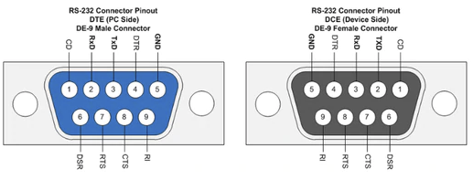
Serial devices show up as USB class 02h which is “Communications and CDC control.”

the USB host driver maps this USB device into a virtual COMnn port with nearest available number, so PC applications can use it as an usual COM port.

When the host wants to send a UART data, it issues an OUT packet with 1 byte of data. The bridge receives the serial byte into a parallel buffer (at USB speed), and then stuffs the received parallel byte into the parallel side of UART for transmitting it at UART's speed.

Before communicating over UART, the USB side must configure the UART for proper baud rate, stop signal length, and use of flow control, as in case of usual UART in a PC. This is virtually transparent to application terminals, and the terminals use the usual interface to set these parameters up.

The FTDI chip that the iCEBreaker uses is a “USB to serial UART interface with optional clock generator output.”

https://ftdichip.com/usb-bridge-ics/
The USB Communications Device Class (CDC) is the most popular, and pops up as a virtual COM port on its host.
UART: Universal Asynchronous Transmitter Receiver.
Full Duplex Serial Communication
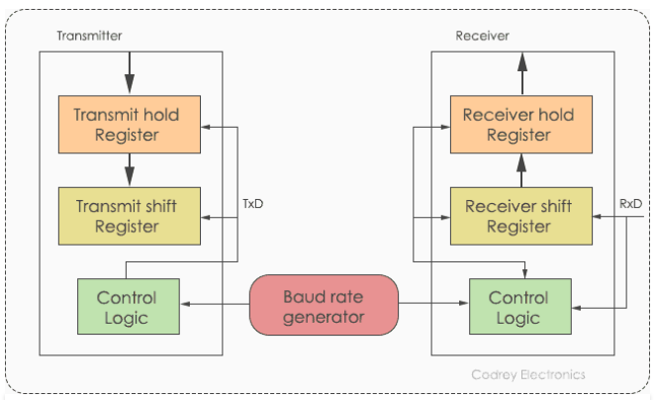
The Uart frame consists of: 1 start bit, 1 or 2 stop bits, and a parity bit

The hold register holds the entire data; the shift register shifts bits out until the data is sent or received.

The Baud rate Generator can generate speeds ranging from 110bps to 230400

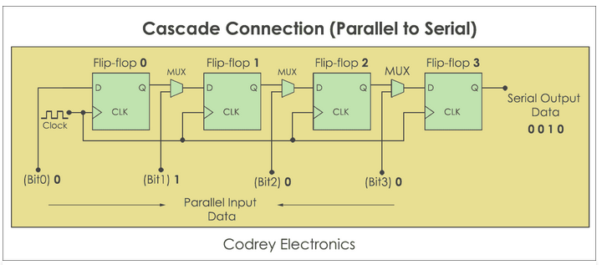
We have a D flip flop for each bit; we have a mux for the connections into each flip flop, this will select between the coresponding bit or the output from the previous flip flop.

Load the bits into all of the flip flops, then switch the mux to the other setting, it will take N clock pulses to get the data to serial output.

On the receiver end, you do the opposite. You take in serial data and convert it into a parallel structure, loading it into the flip flops one at a time. The parallel bus isn’t valid until all of the flip flops have been loaded.
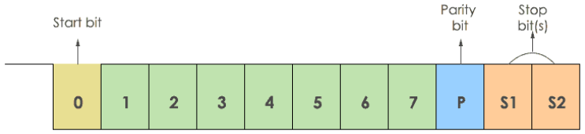
Protocol Format
There is a ‘0’ start bit (looks like its held at 1 otherwise)

For the parity bit; 0 if even number of 1s, 1 if odd number of 1s.

Transmission
LSB is always sent first
There is a start and stop bit, if you have parity, your ratio of data transmistted to total bits transmitted is 7/10

There is UART and then there is USART: USART is synchronous (but can also be asynchrnous), the clock must be provided by the sending device.

The baud rate is the rate at which the data is transmitted. For example, 9600 baud means 9600 bits per second.

The FPGA is continuously sampling the line. Once it sees the line transition from high to low, it knows that a UART data word is coming. This first transition indicates the start bit. Once the beginning of the start bit is found, the FPGA waits for one half of a bit period. This ensures that the middle of the data bit gets sampled. From then on, the FPGA just needs to wait one bit period (as specified by the baud rate) and sample the rest of the data. The figure below shows how the UART receiver works inside of the FPGA. First a falling edge is detected on the serial data line. This represents the start bit. The FPGA then waits until the middle of the first data bit and samples the data. It does this for all eight data bits.

